HandsMen Threads Salesforce Project Documentation
Prepared for Project Review
Salesforce Platform Developer Project

Data Model Automation Security Apex Testing

Contents
Section | Description
1 | Project Overview
2 | Objectives and Implementation Scope
3 | Requirement Analysis and Data Model
4 | Salesforce Configuration and Data Security
5 | Data Quality and Business Rules
6 | Email Templates and Process Automation
7 | Apex Triggers and Handler Logic
8 | Batch Apex and Scheduled Processing
9 | User Interface and Sample Records
10 | Functional Testing Evidence
11 | Conclusion

This report presents the HandsMen Threads Salesforce implementation in a concise review format. Each numbered figure panel identifies the exact screenshot that should be captured from the Salesforce developer org before submission.

1 Project Overview
HandsMen Threads is a Salesforce solution for a fashion business that manages customers, products, orders, inventory, and marketing campaigns. The project brings operational data into one platform and applies automation to improve customer communication, stock control, loyalty management, and order processing.
The implementation combines custom objects, custom fields, lookup and master detail relationships, formula fields, validation rules, profiles, roles, permission sets, email templates, record triggered flows, scheduled automation, Apex triggers, Batch Apex, and Scheduled Apex.

Main Business Outcomes
- Send an automatic confirmation message when an order is confirmed.
- Update customer loyalty status from purchase history.
- Notify the inventory team when stock falls below the defined threshold.
- Calculate order totals and deduct stock when confirmed orders are processed.
- Process inventory updates in bulk through scheduled Apex.

Technology Used
Area | Salesforce Feature
Data | Custom objects, custom fields, formula fields, relationships
Automation | Record triggered flows and scheduled flow
Development | Apex classes, triggers, handler pattern, Batch Apex, Scheduled Apex
Security | Profiles, roles, users, permission sets, object access
Communication | Classic email templates and email alerts

2 Objectives and Implementation Scope

2.1 Project Objectives
- Create a structured Salesforce data model for customers, products, orders, inventory, and campaigns.
- Maintain accurate customer, order, and stock information through UI level validation.
- Automate order confirmation, low stock alerts, and loyalty status updates.
- Apply role based access so teams can work only with relevant business records.
- Use Apex for order validation, total calculation, stock deduction, and bulk processing.

2.2 Current Implementation Scope
Area | Included Implementation | Review Evidence
Data model | Five custom objects with business fields and relationships | Object Manager and Schema Builder
Data quality | Formula fields and validation rules | Field and validation rule screens
Security | Profile, role hierarchy, users, permission set | Setup security screens
Automation | Order, stock, and loyalty flows | Flow Builder canvases
Development | Handler, triggers, batch, and scheduler | Apex class and trigger screens
Testing | Sample records, error messages, updates, and emails | Lightning records and test results

3 Requirement Analysis and Data Model
The data model separates master data from transaction data. Customer and product records store reusable business information. Orders capture transactions, inventory records track stock by product, and marketing campaigns connect promotional activity with customers.
Custom Object | Key Fields | Business Purpose
HandsMen Customer | Name, First Name, Last Name, Email, Phone, Loyalty Status, Total Purchases | Stores customer identity, contact, and loyalty details.
HandsMen Product | Name, SKU, Price, Stock Quantity | Stores the product catalogue and pricing.
HandsMen Order | Order Number, Status, Quantity, Total Amount, Customer, Product | Captures customer purchases and order status.
Inventory | Inventory Number, Warehouse, Stock Quantity, Product | Tracks stock levels for each product.
Marketing Campaign | Campaign Number, Start Date, End Date, Customer | Stores promotional campaigns and customer association.

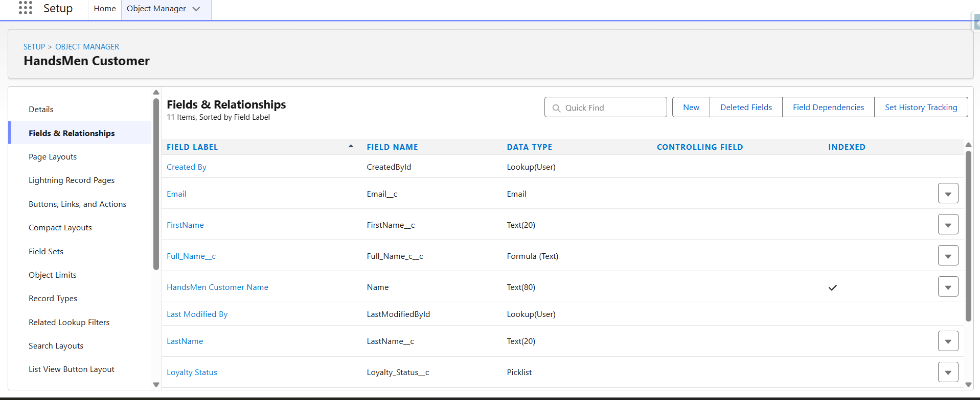
Figure 1 HandsMen Customer object fields including email phone loyalty status and total purchases

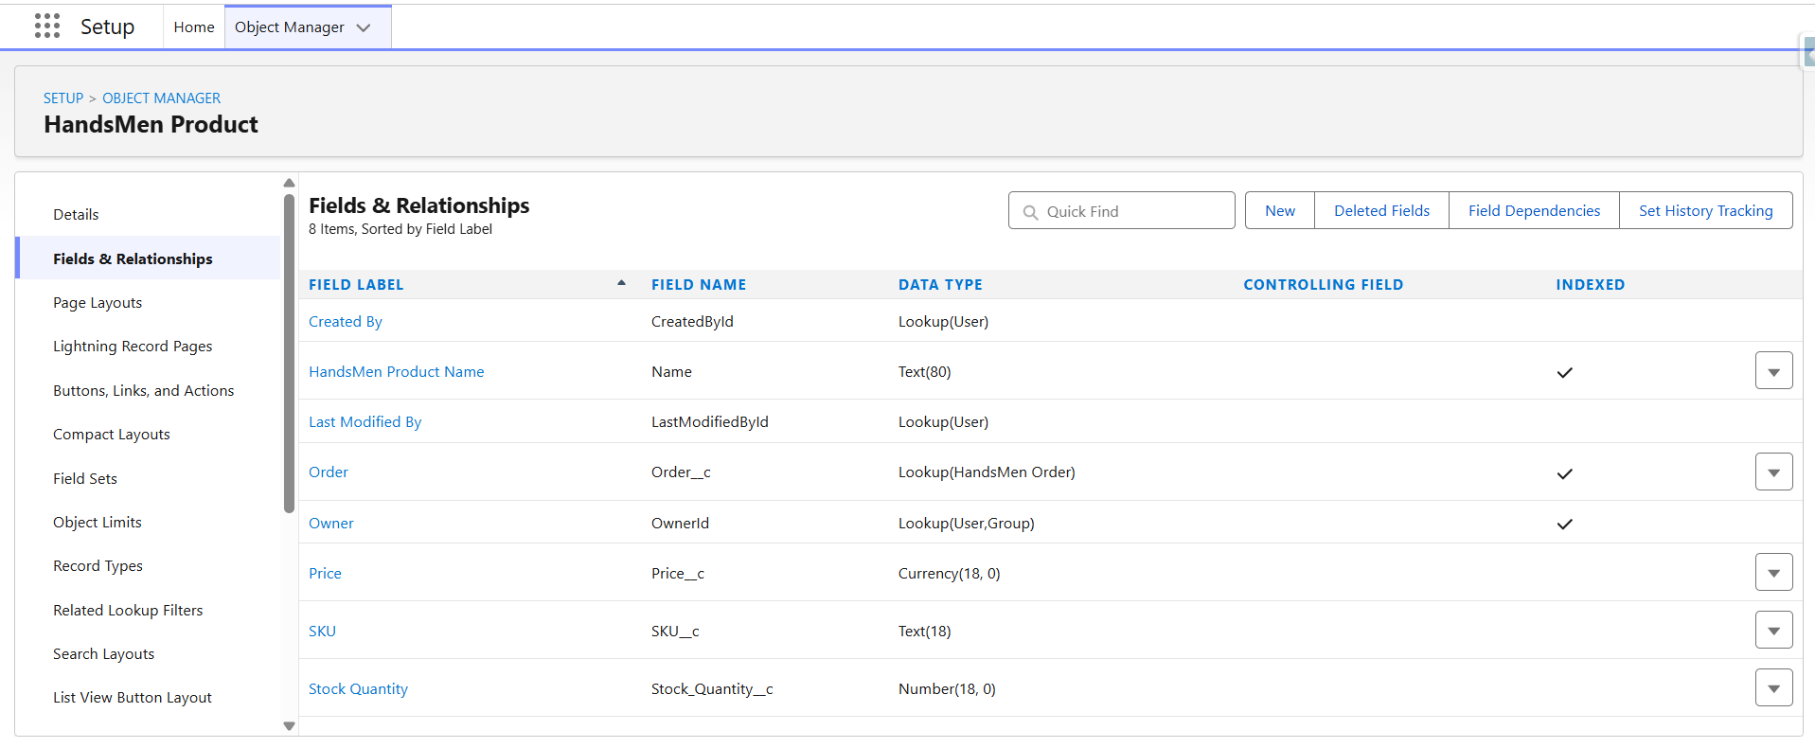
Figure 2 HandsMen Product object fields including SKU price and stock quantity

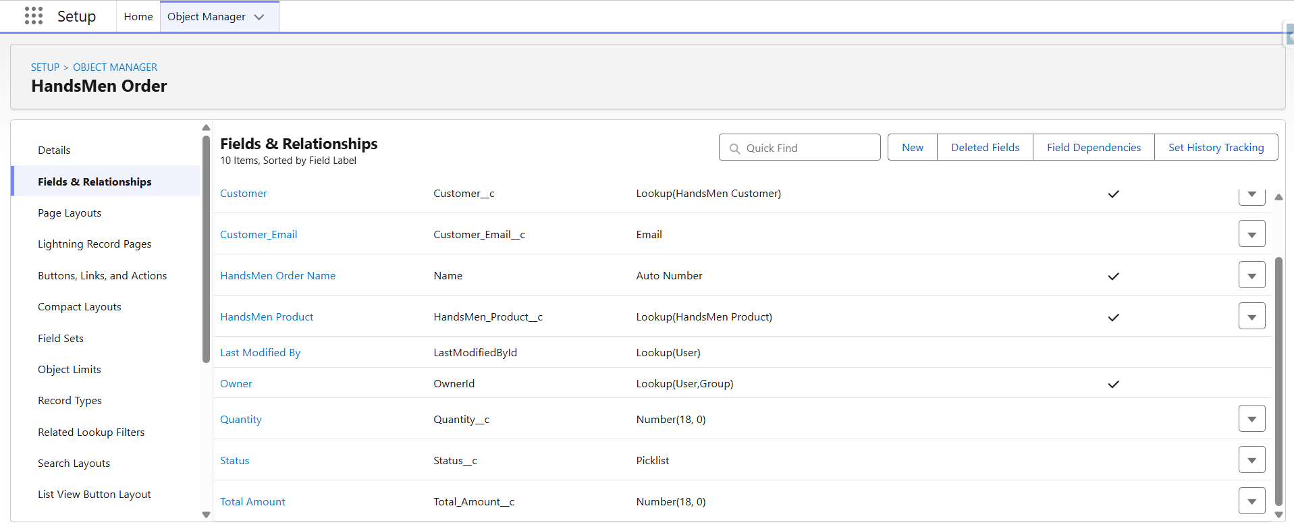
Figure 3 HandsMen Order object fields and relationships including status quantity total amount customer and product

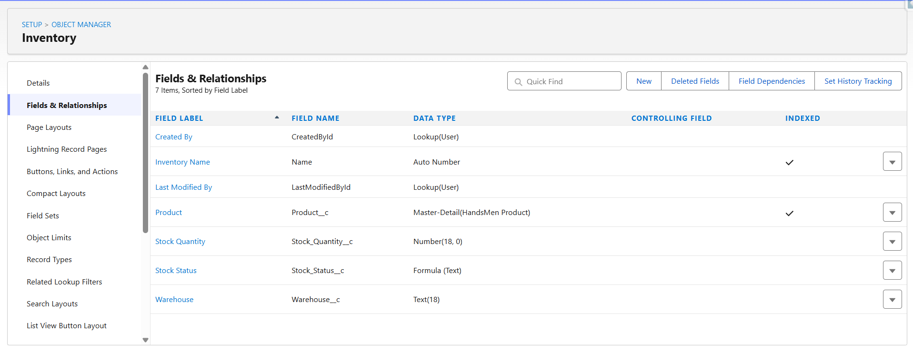
Figure 4 Inventory object fields and relationship including warehouse stock quantity and related product

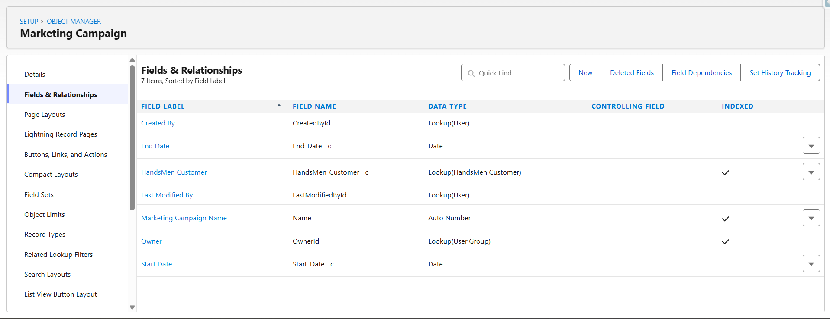
Figure 6 Marketing Campaign object fields and relationship including campaign dates and related customer

3.1 Relationships and Important Fields
Child Object | Relationship | Related Object | Purpose
Marketing Campaign | Lookup | HandsMen Customer | Associates a campaign with a customer.
HandsMen Product | Lookup | HandsMen Order | Connects product information to an order as documented.
HandsMen Order | Lookup | HandsMen Customer | Links each order to the purchasing customer.
Inventory | Master Detail | HandsMen Product | Makes inventory dependent on its product.

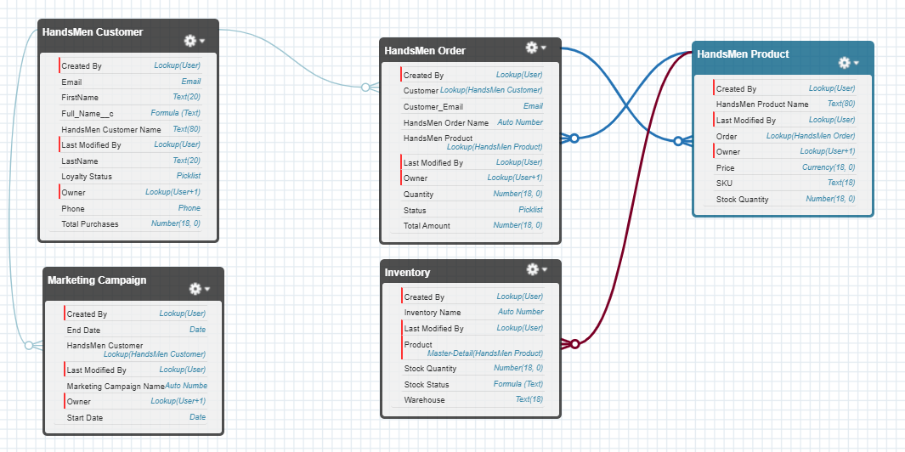
Figure 2 Schema Builder Data Model

4 Salesforce Configuration and Data Security
The project uses custom tabs and a dedicated navigation workspace so users can open customer, product, order, inventory, and campaign records from Lightning Experience. Security is controlled through profiles, roles, and a permission set.
Role | Intended Access
Sales Manager | Full access to customer and order records.
Inventory Manager | Read and edit access to inventory and product records.
Marketing Manager or Team | Read customer records and manage marketing campaign records.

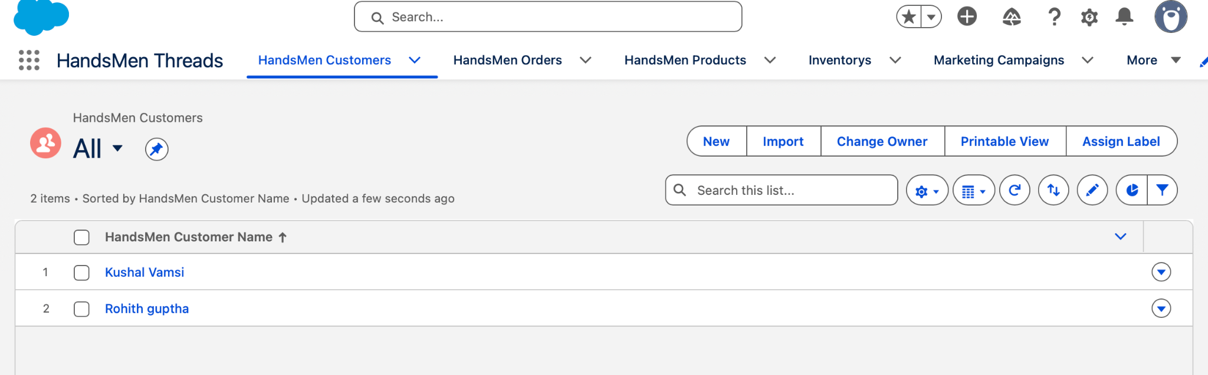
Figure 4 HandsMen Lightning App and Navigation
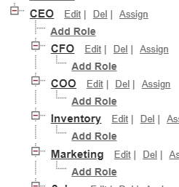
Figure 5 Role Hierarchy

4.1 Profiles Users and Permission Sets
Security Item | Configuration | Purpose
Profile | Platform 1 cloned from Standard User | Provides the base Salesforce Platform access.
User | Sales user assigned to Sales role | Supports customer and order activities.
User | Inventory user assigned to Inventory role | Supports product and inventory activities.
Permission Set | Permission Platform 1 | Adds create, read, edit, and delete access for selected project objects.

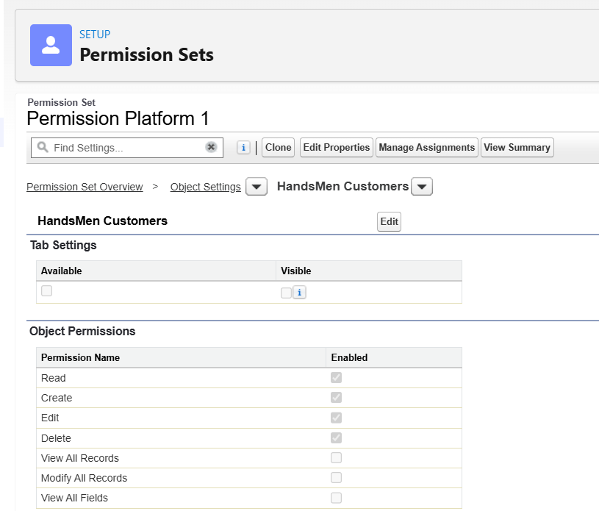
Figure 1 HandsMen Customer permissions configured in Permission Platform 1
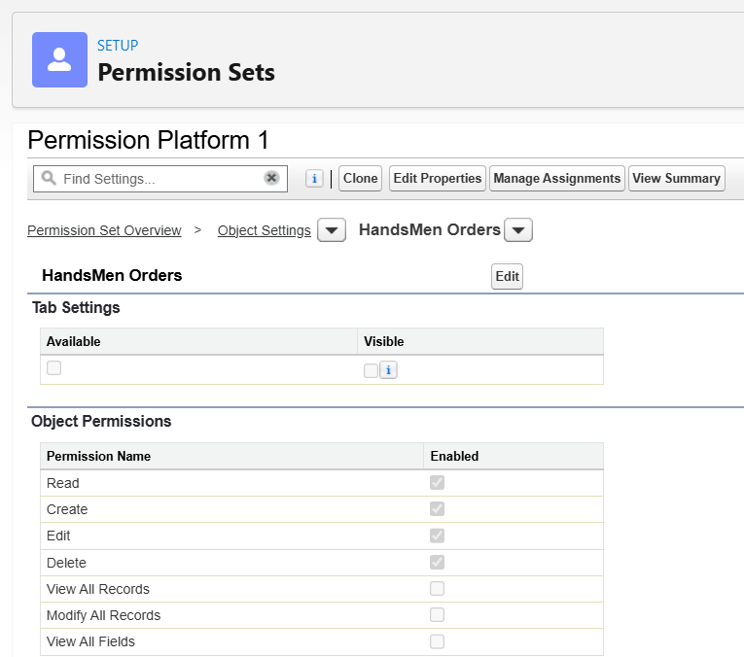
Figure 2 HandsMen Order permissions configured in Permission Platform 1

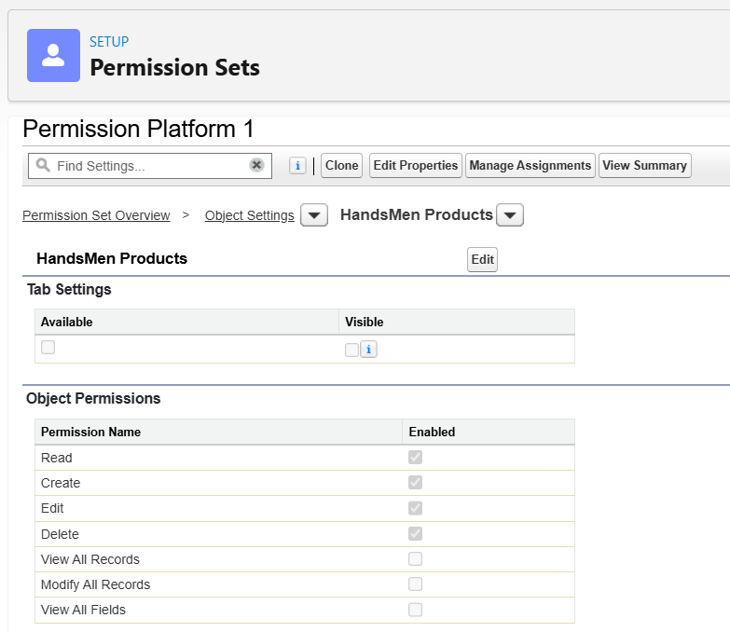
Figure 3 HandsMen Products permissions configured in Permission Platform 1

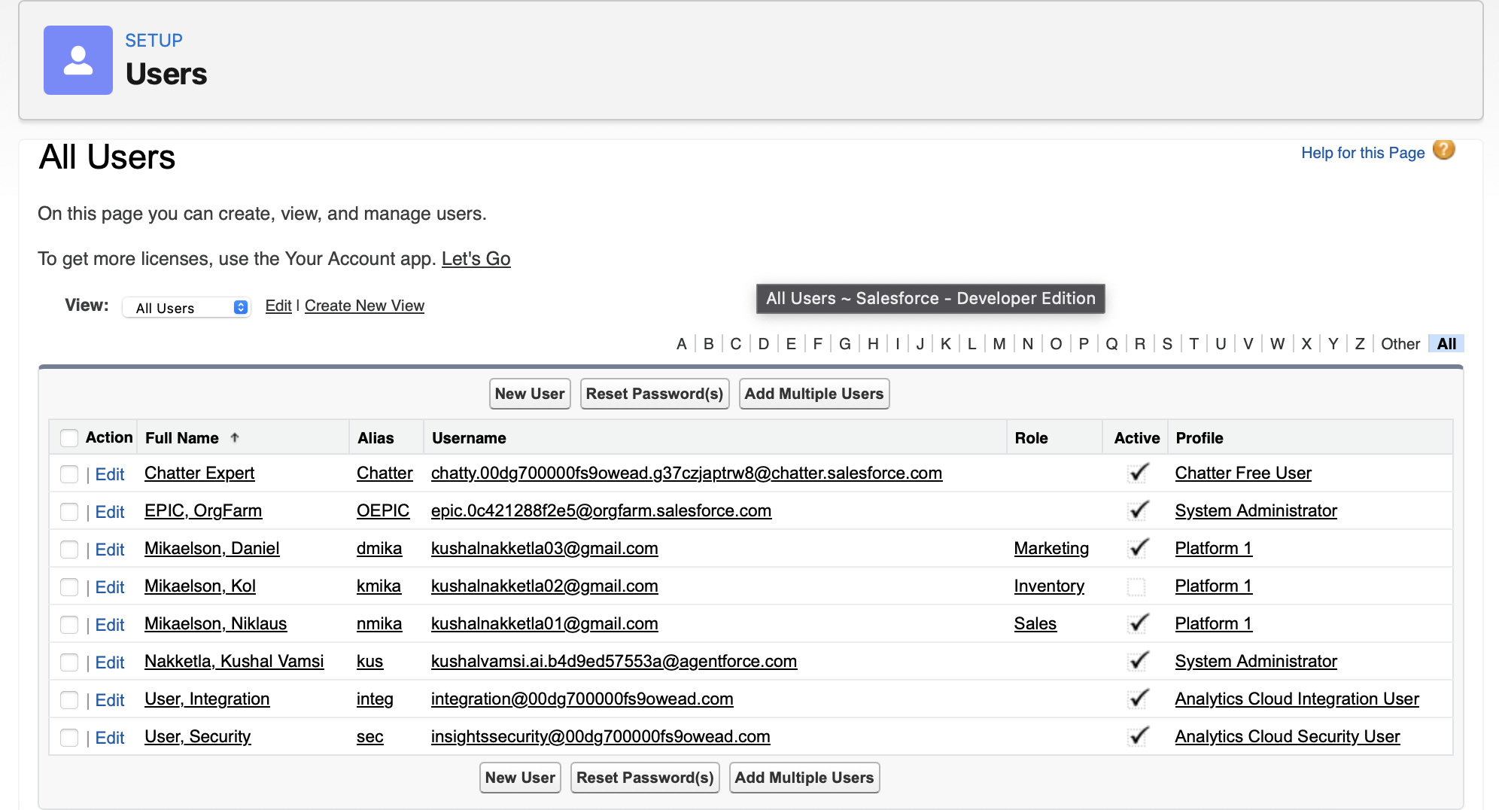
Figure 4 Project Users and Assigned Roles

5 Data Quality and Business Rules

5.1 Formula Fields
Object | Formula Field | Return Type | Formula
HandsMen Customer | Full Name | Text | FirstName__c + " " + LastName__c
Inventory | Stock Status | Text | IF(Stock_Quantity__c > 10, "Available", "Low Stock")

5.2 Validation Rules
Object | Rule | Condition | Expected Message
HandsMen Order | Total Amount | Total_Amount__c <= 0 | Please enter a correct amount.
Inventory | Stock Quantity | Stock_Quantity__c <= 0 | Inventory count cannot be less than or equal to zero.
HandsMen Customer | Email | NOT(CONTAINS(Email__c, "@gmail.com")) | Please enter a correct Gmail address.

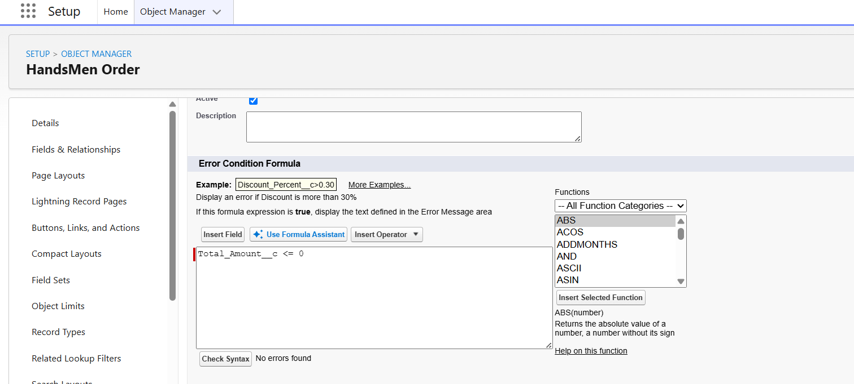
Figure 1 Total Amount field configuration and successful syntax validation
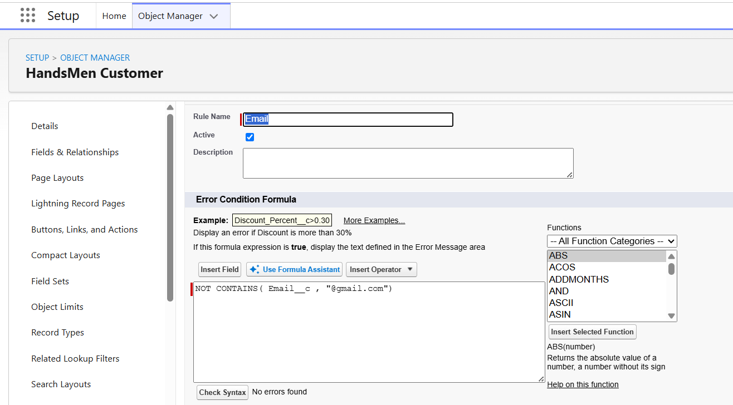
Figure 2 Email formula field configuration and successful syntax validation
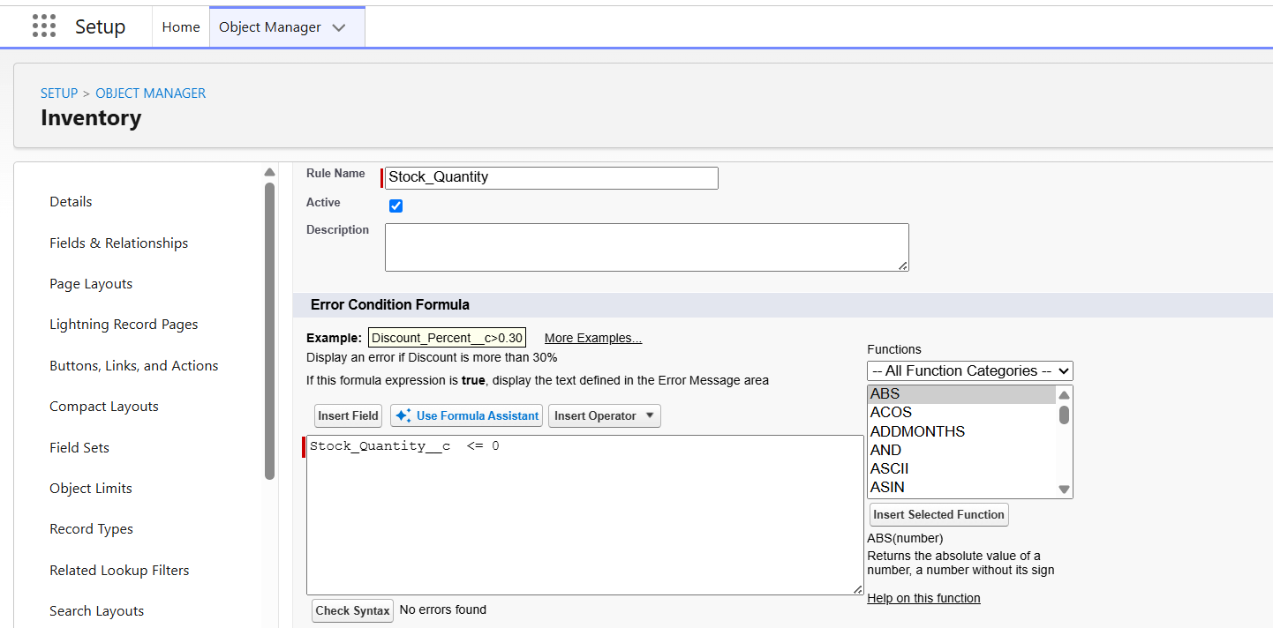
Figure 3 Stock Quantity configuration and successful syntax validation

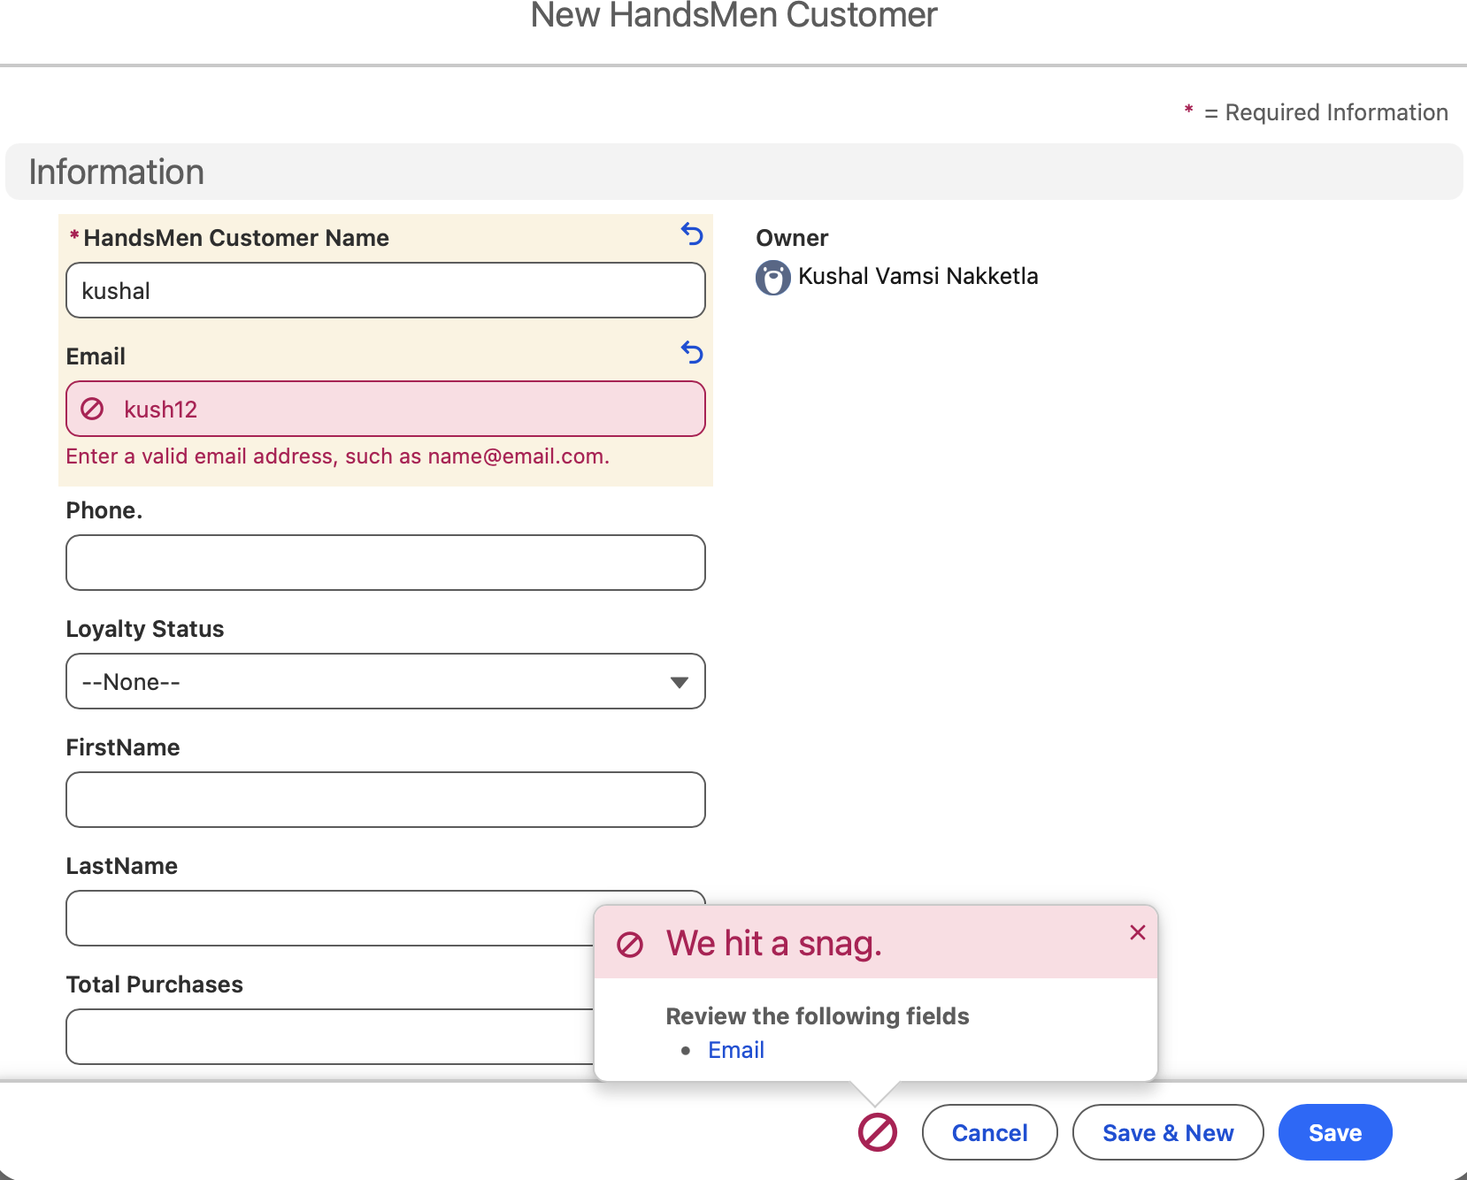
Figure 3 Customer email validation rule preventing an invalid email from being saved

6 Email Templates and Process Automation

6.1 Email Templates and Alerts
Template | Type | Used For
Order Confirmation | HTML | Sent when an order changes to Confirmed.
Low Stock Alert | Text | Sent to the inventory team when stock is below five.
Loyalty Program Email | HTML | Supports customer loyalty communication.

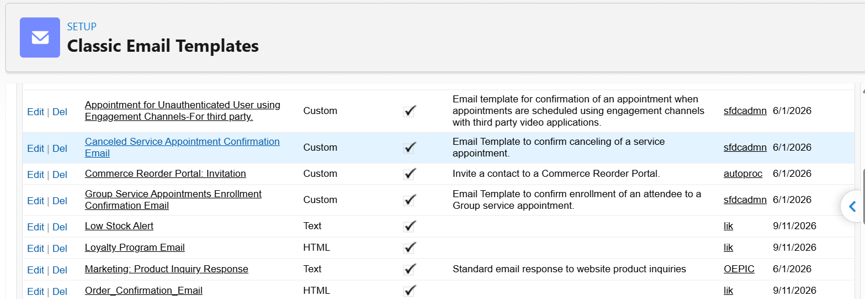Figure 10 Email Templates List

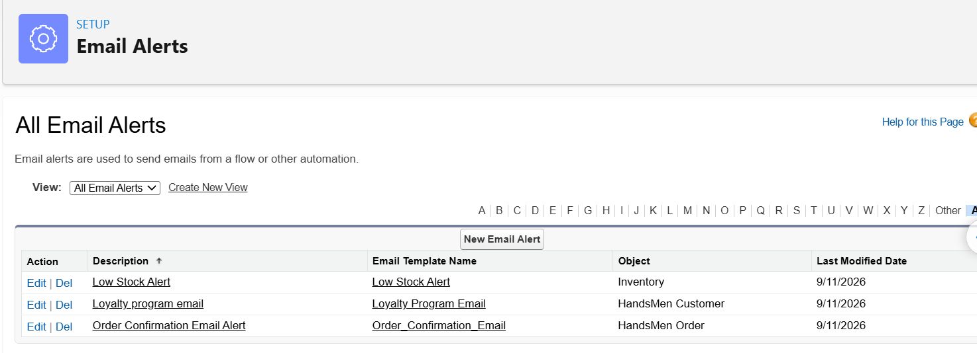Figure 11 Order Confirmation Email Alert

6.2 Salesforce Flows
Flow | Type | Start Condition | Action
Order Confirmation Flow | Record Triggered | Order status changes to Confirmed | Sends the order confirmation email alert.
Stock Alert Flow | Record Triggered | Inventory stock quantity is below 5 | Sends a low stock email alert.
Loyalty Status Update Flow | Schedule Triggered | Runs daily | Sets Gold, Silver, or Bronze from Total Purchases.

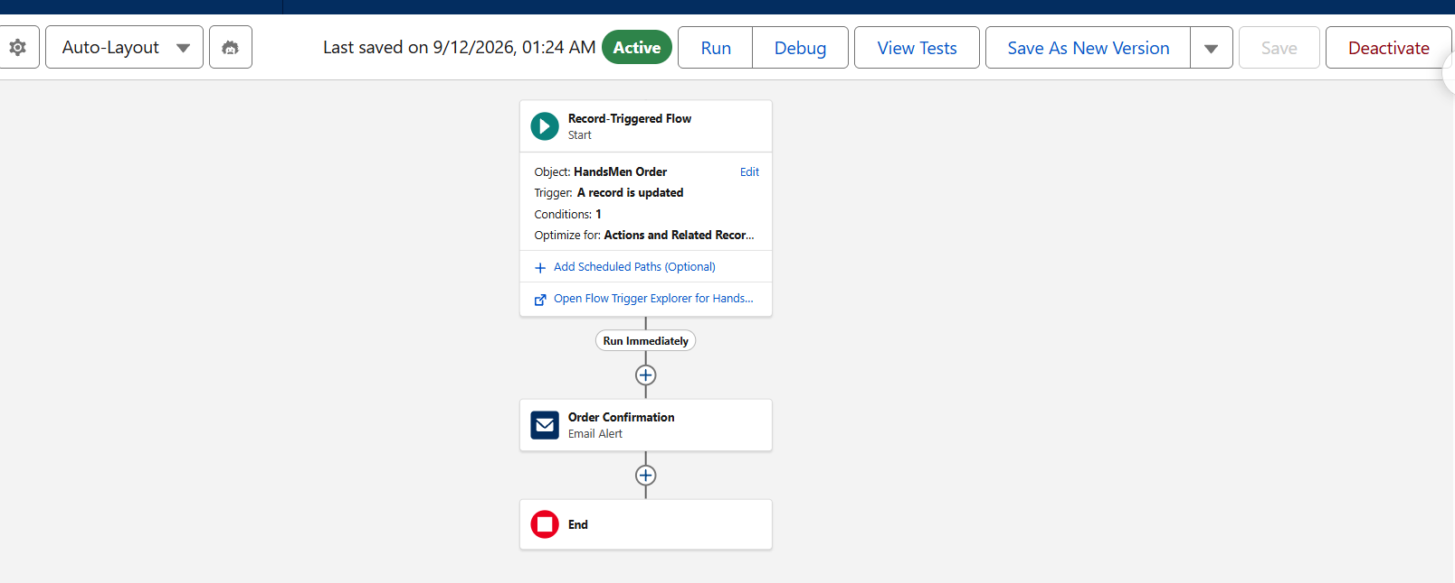Figure 12 Order Confirmation Flow
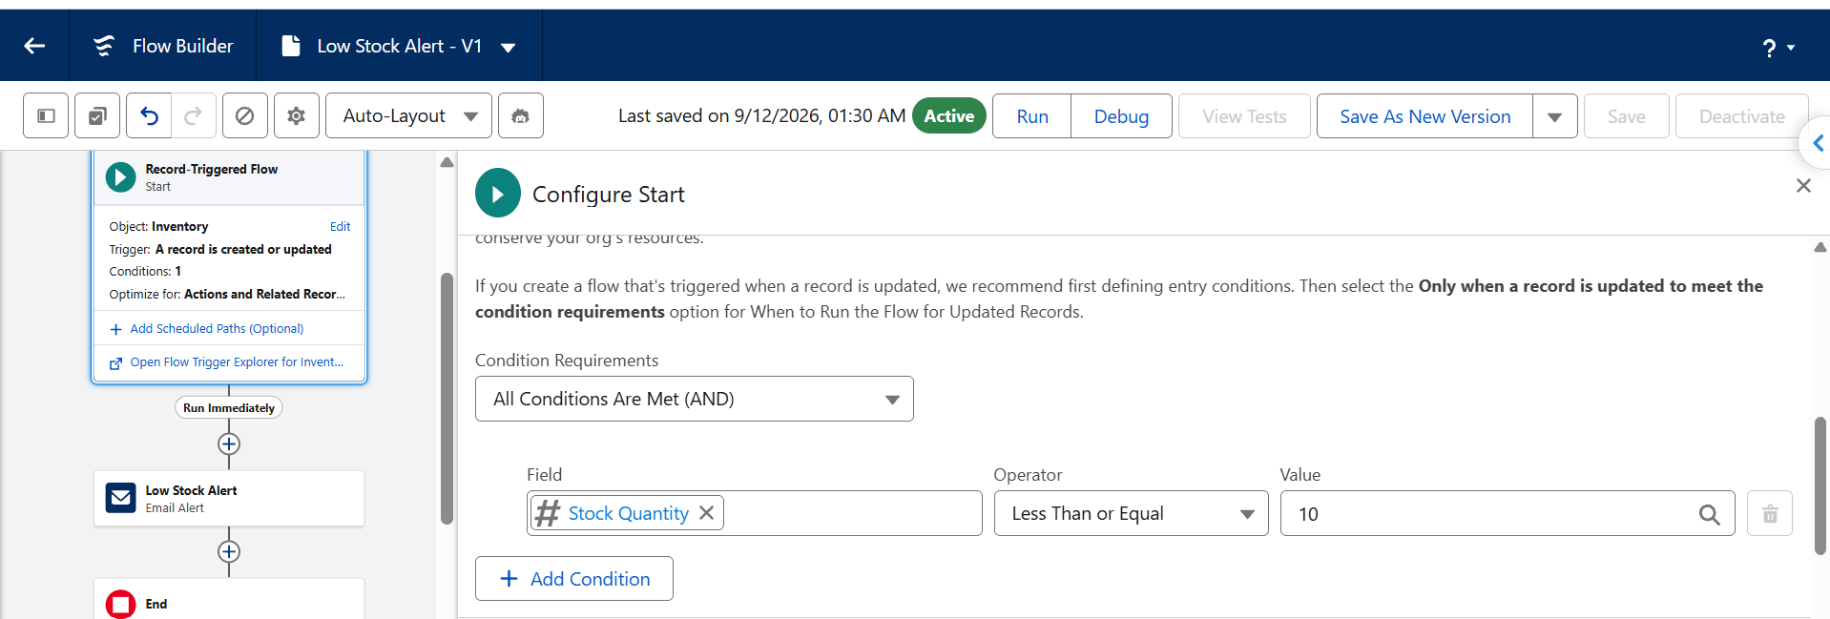Figure 13 Stock Alert Flow
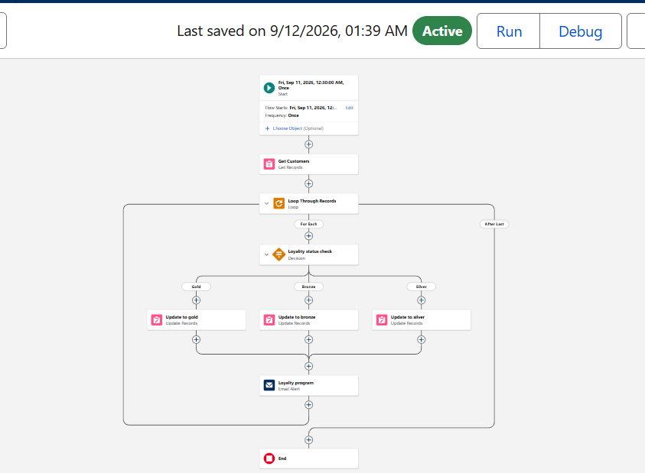
Figure 14 Loyalty Status Update Flow
7 Apex Triggers and Handler Logic
Apex is used where record processing requires reusable logic and transaction level enforcement. The order trigger delegates status based quantity validation to OrderTriggerHandler so the trigger remains small and the rule can be maintained in one class.
Status | Quantity Rule | Outcome
Confirmed | Quantity must be greater than 500 | The record is blocked when the quantity is missing or too low.
Pending | Quantity must be greater than 200 | The record is blocked when the quantity is missing or too low.
Rejection | Quantity must equal 0 | Rejected orders cannot contain a positive quantity.

trigger OrderTrigger on HandsMen_Order__c (before insert, before update) {
OrderTriggerHandler.validateOrderQuantity(Trigger.new);
}
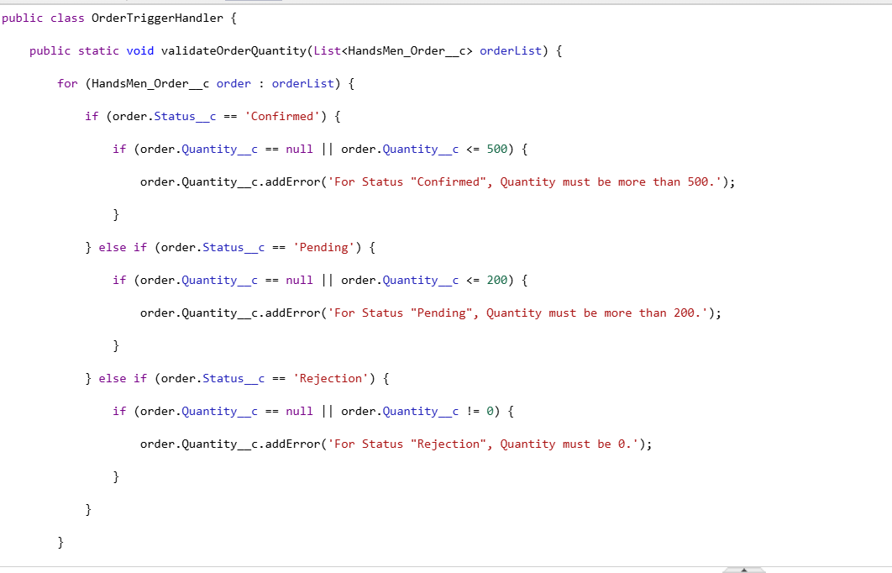Figure 15 OrderTriggerHandler Apex Class

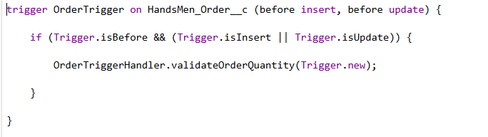
Figure 16 OrderTrigger Apex Trigger
7.1 Order Total and Stock Deduction Triggers
Apex Artifact | Event | Responsibility
Order Total Trigger | Before insert and before update | Reads the related product price and sets Total Amount to Quantity multiplied by Price.
Stock Deduction Trigger | After insert and after update | When an order becomes Confirmed, totals ordered quantity by product and reduces Inventory Stock Quantity.

The stock deduction design collects product identifiers in a set, aggregates quantities in a map, queries matching inventory records once, and performs one bulk update. This avoids database operations inside the record loop.
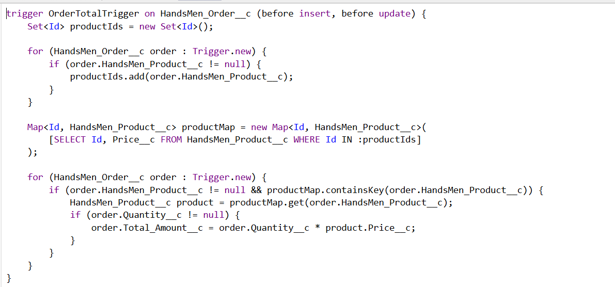Figure 17 Order Total Trigger
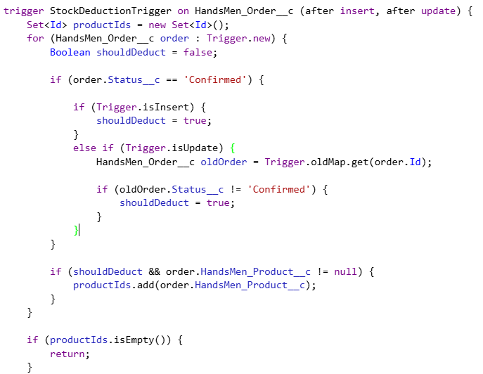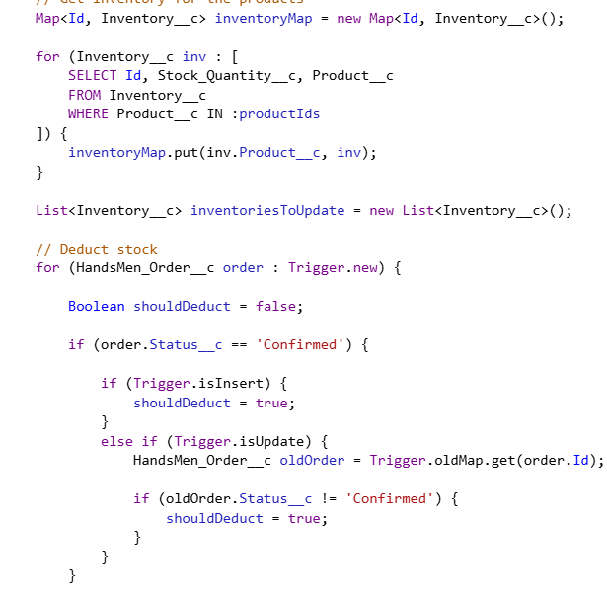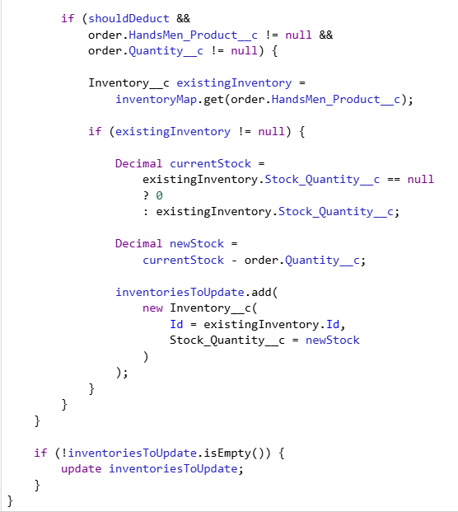
Figure 18 Stock Deduction Trigger
8 Batch Apex and Scheduled Processing
InventoryBatchJob implements Database Batchable and Schedulable. It identifies low stock products, applies the restocking logic in manageable batches, and can be scheduled for automatic execution.
Method or Process | Responsibility | Expected Evidence
start | Queries products that meet the low stock condition. | SOQL query and selected fields.
execute | Adds the restock quantity and updates records in bulk. | Loop, update list, and DML statement.
finish | Records that inventory synchronization completed. | Completion debug statement.
Schedulable execute | Starts the batch with a scope of 200. | Database executeBatch call.
Scheduled job | Runs Daily Inventory Sync automatically. | Scheduled Jobs entry and next run time.

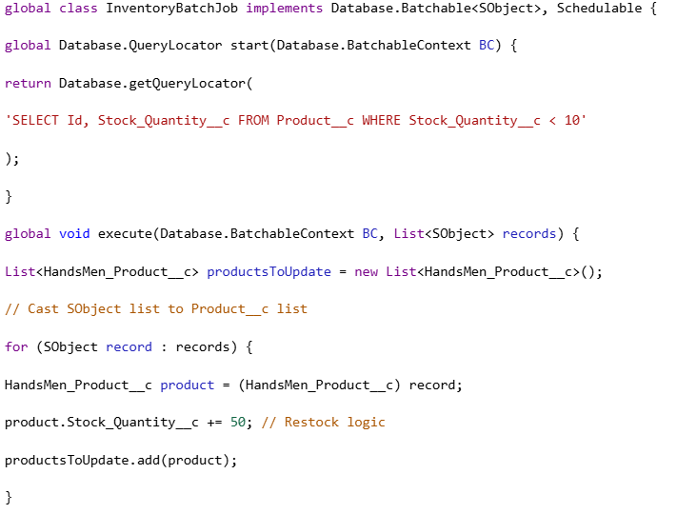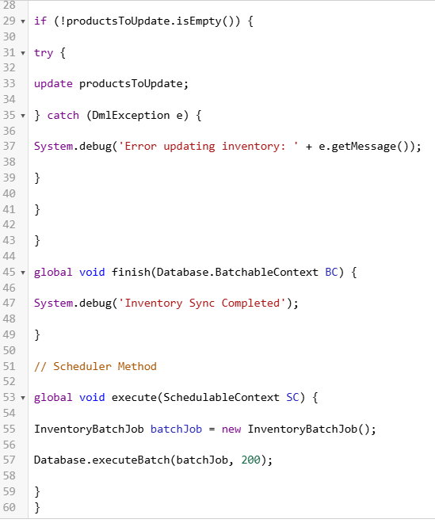
Figure 19 InventoryBatchJob Apex Class

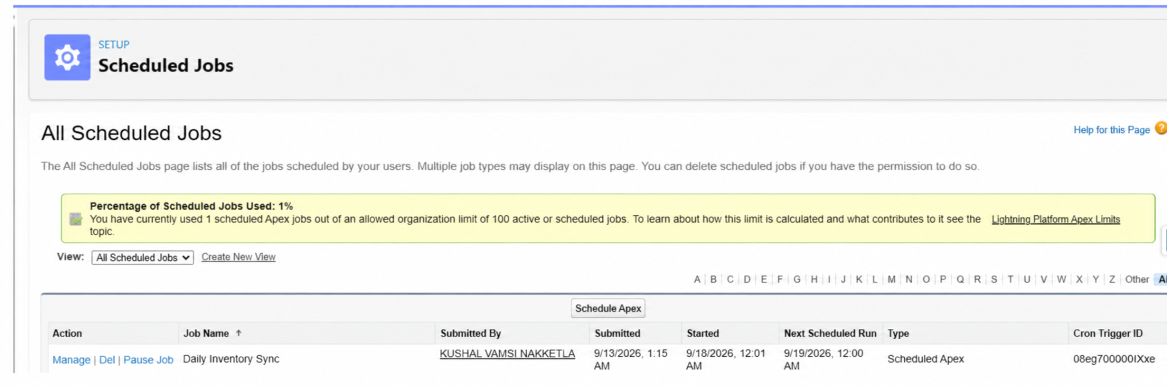

Figure 20 Scheduled Inventory Job

9 User Interface and Sample Records
Sample records should demonstrate that the configured fields, relationships, and automation are available to business users in Lightning Experience. Use realistic but non-sensitive data and keep the browser zoom between 80 and 100 percent so labels and values remain readable.
Record | Recommended Fields to Show
HandsMen Customer | Full name, email, phone, loyalty status, total purchases
HandsMen Product | Product name, SKU, price, stock quantity
HandsMen Order | Order number, customer, product, status, quantity, total amount
Inventory | Inventory number, product, warehouse, stock quantity, stock status
Marketing Campaign | Campaign number or name, dates, related customer

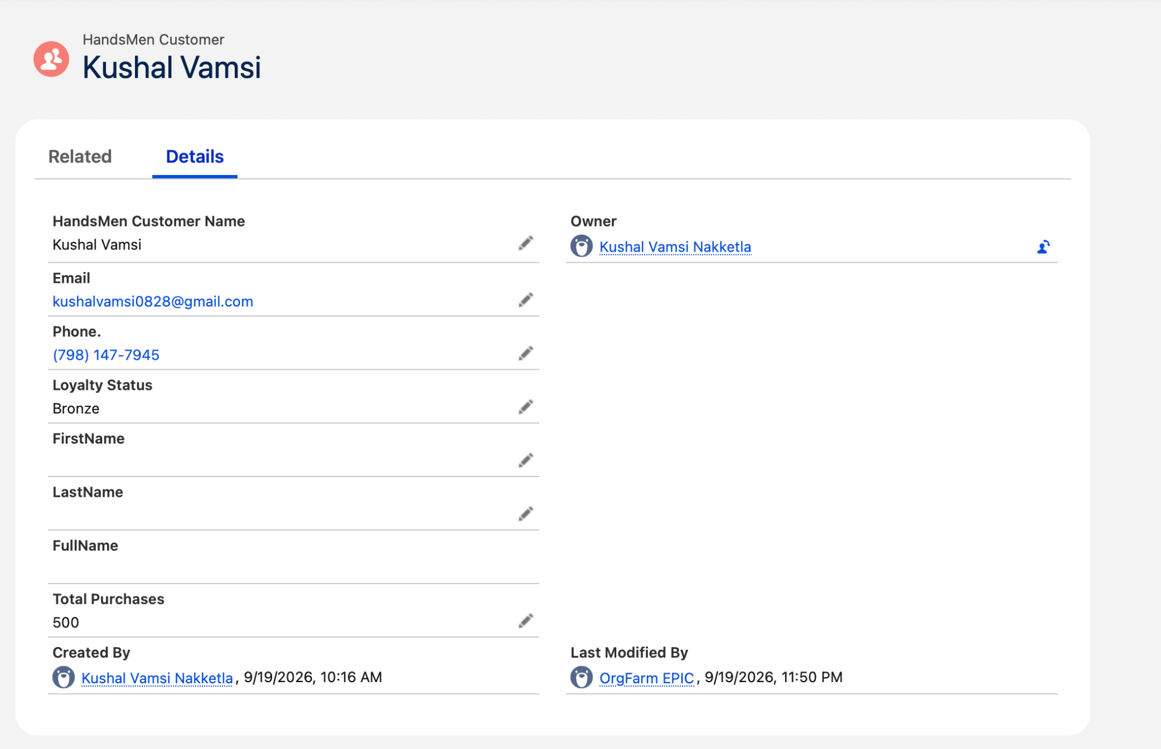
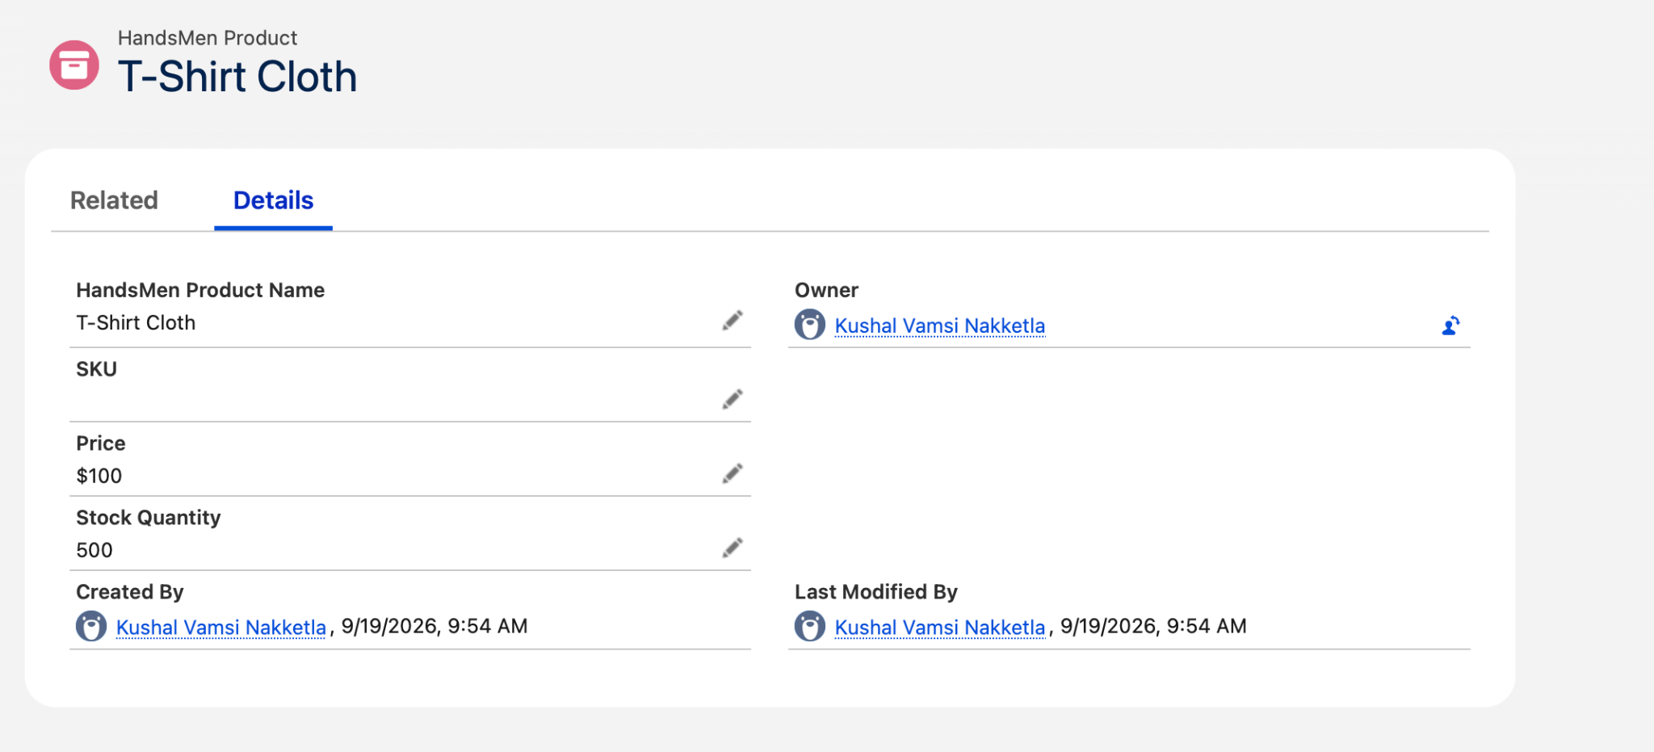
Figure 21 Customer and Product Sample Records
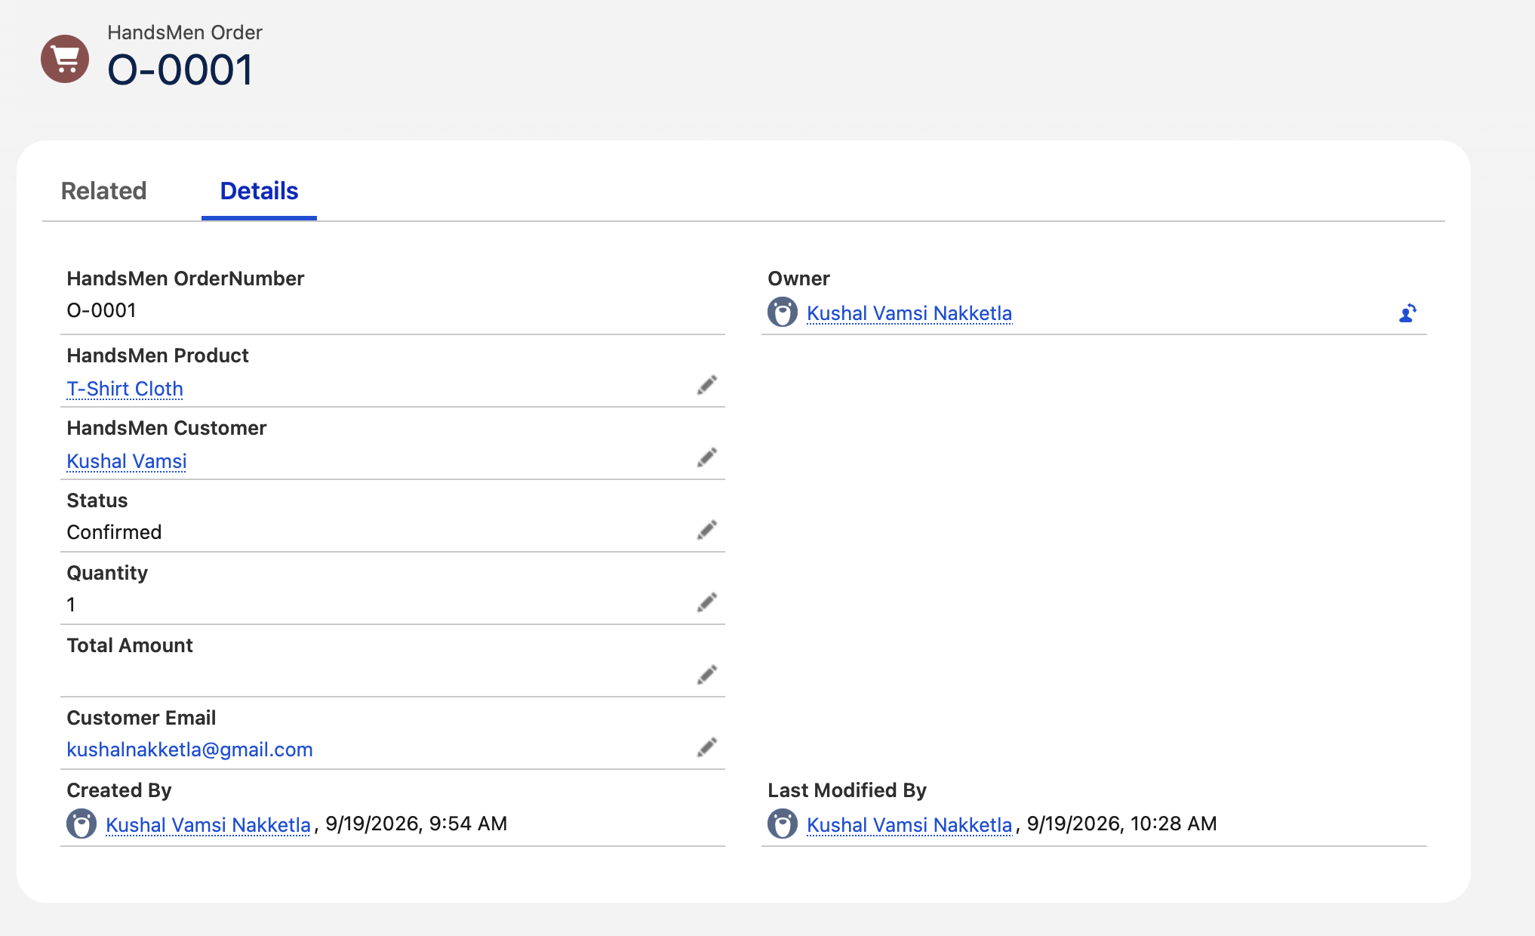Figure 22 Order and Inventory Sample Records

10 Functional Testing Evidence
Functional testing should show both configuration and business outcomes. Capture the action and its result, and use before and after screenshots where a value changes.
Test Case | Action | Expected Result | Evidence
Order quantity validation | Save a status and quantity combination that violates the handler rule. | Save is blocked with the Apex error. | Error on Order page
Order total | Create or edit an order with product and quantity. | Total Amount equals Quantity multiplied by Price. | Order values
Stock deduction | Change an order from Pending to Confirmed. | Inventory decreases once by the ordered quantity. | Before and after stock
Order confirmation | Confirm an order. | Customer receives the confirmation email. | Email inbox
Low stock alert | Set stock below 5. | Inventory manager receives an alert. | Email inbox
Loyalty update | Run or debug the scheduled flow with purchase values. | Customer loyalty changes to Gold, Silver, or Bronze. | Flow debug and record
Batch processing | Execute InventoryBatchJob. | Low stock records are processed and the job completes. | Apex Jobs and record

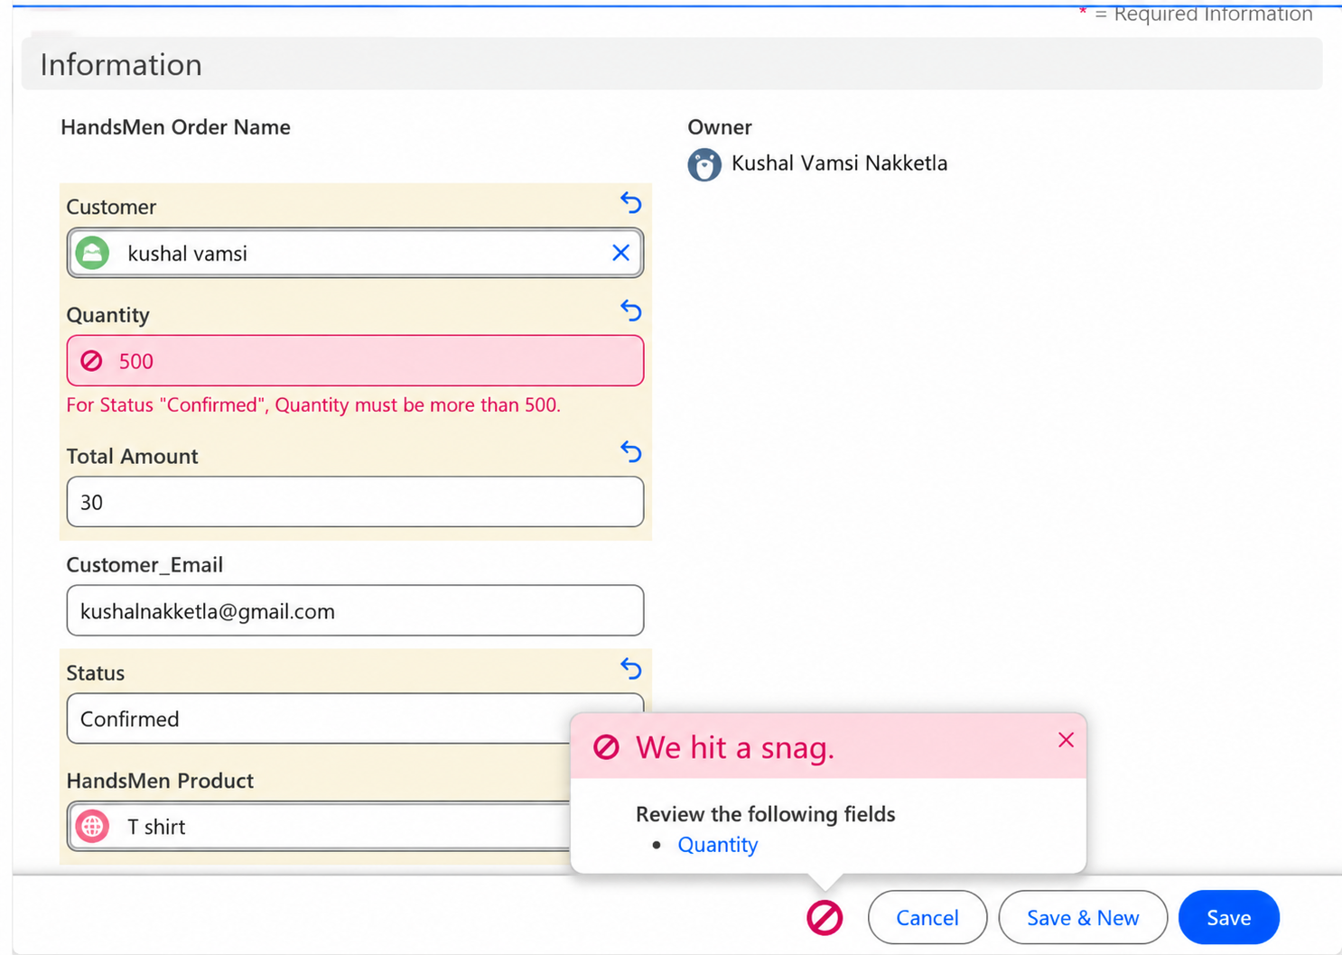
Figure 23 Order Validation Error

10.1 Automation Test Results
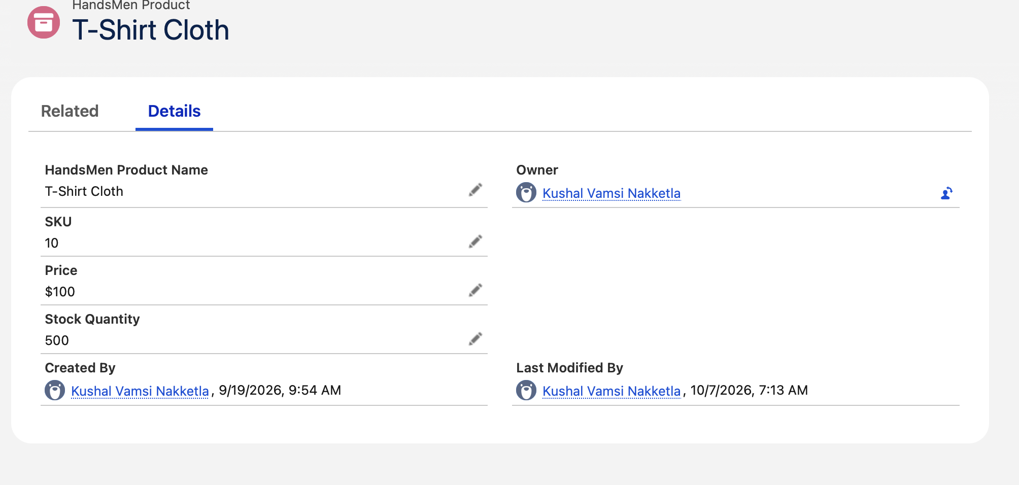
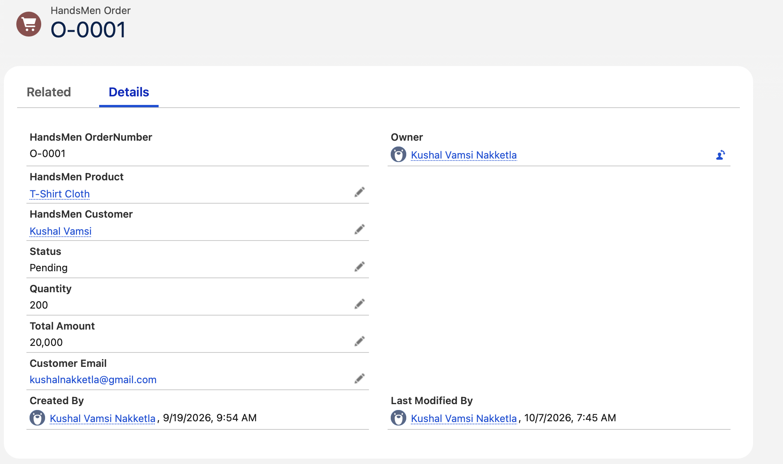
Figure 24 Order Total Calculation
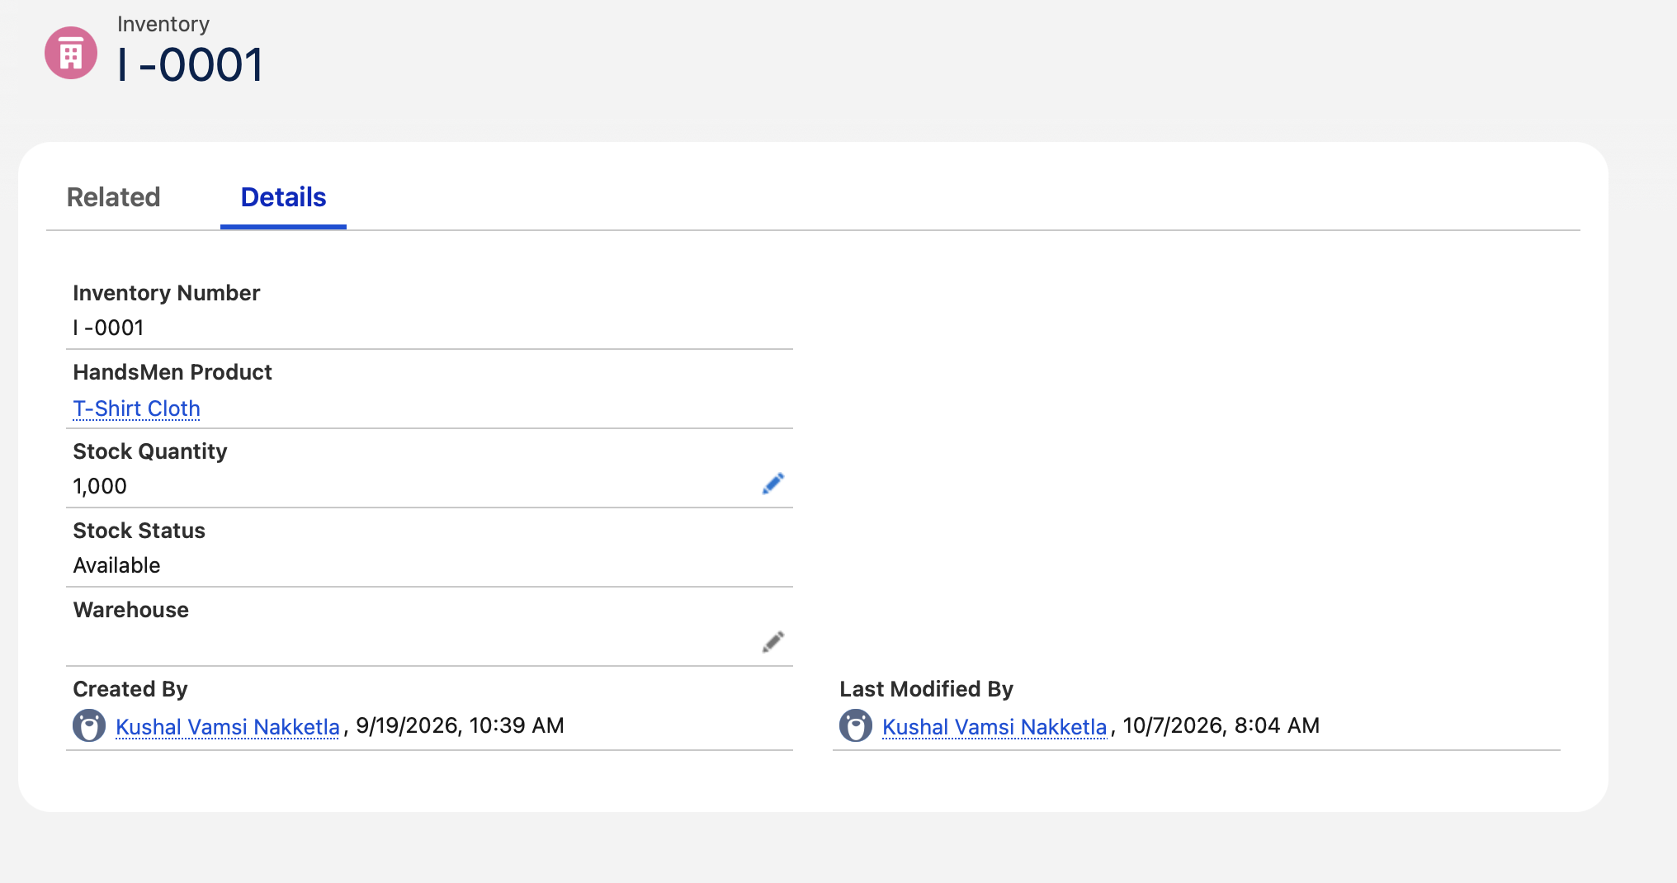
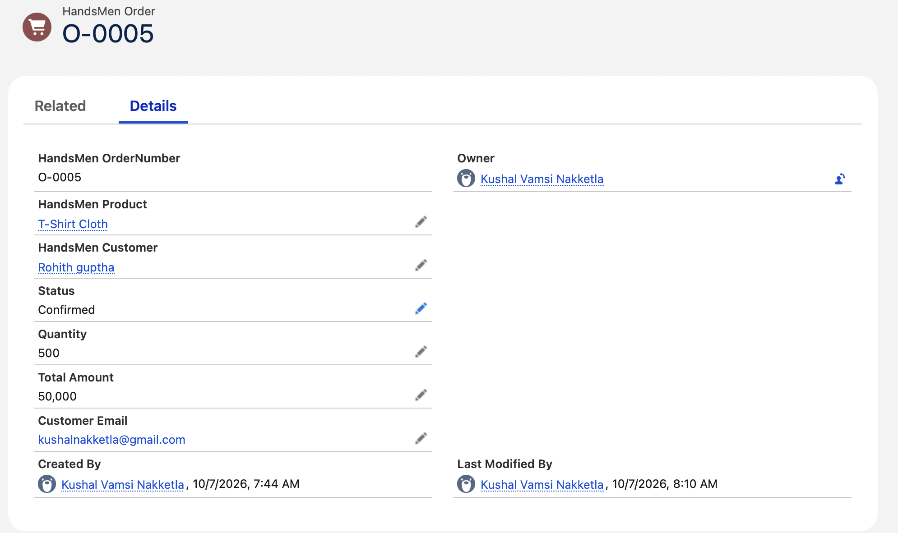
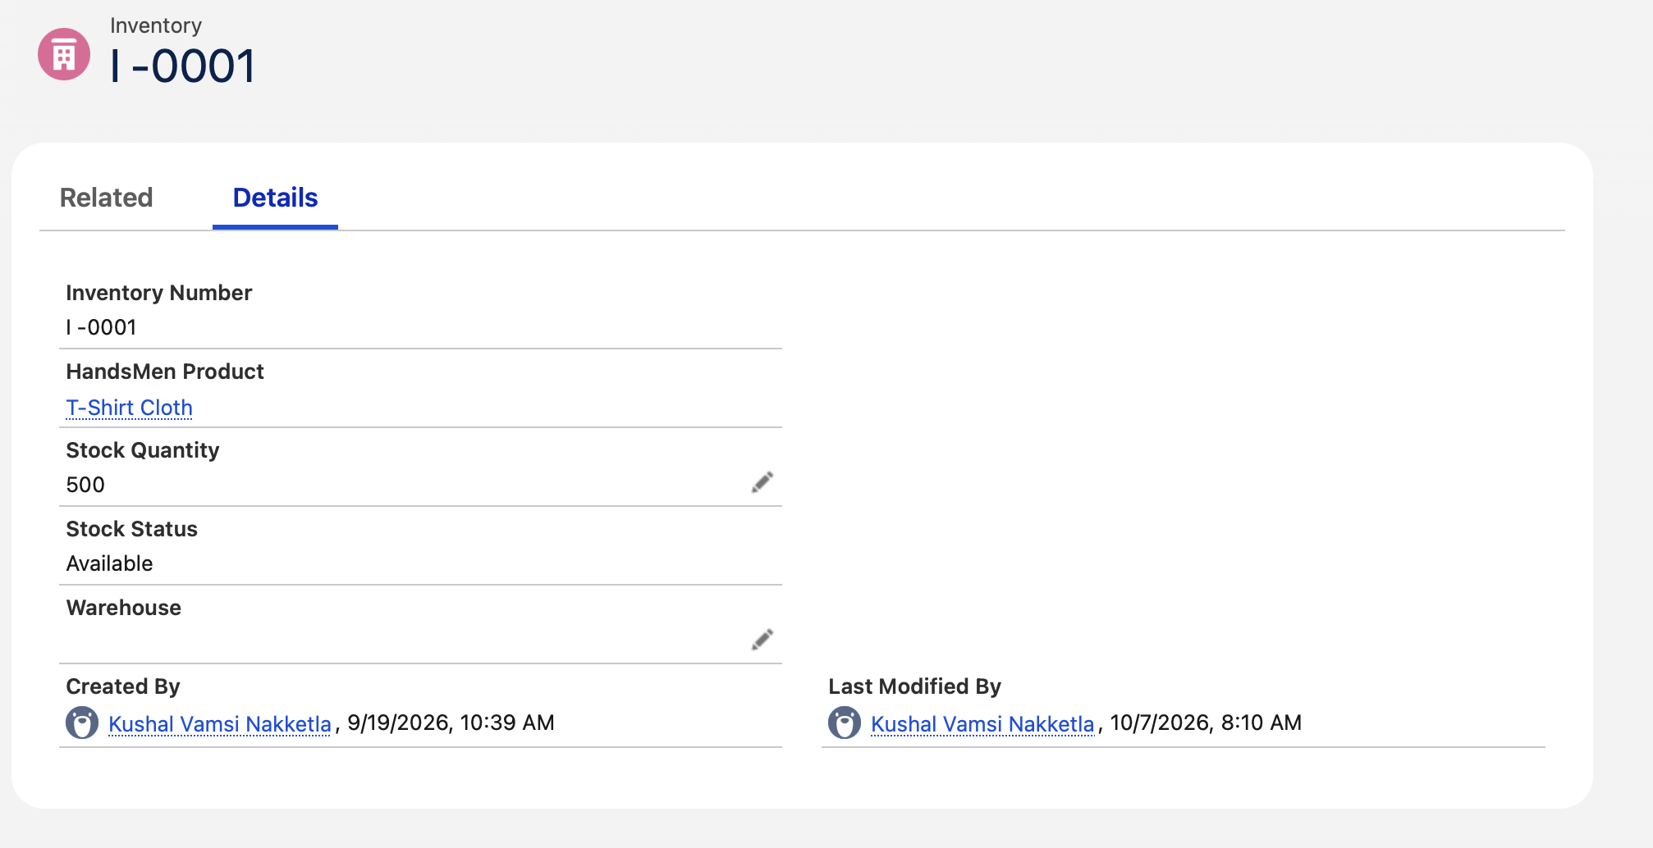
Figure 25 Inventory Before and After Confirmation
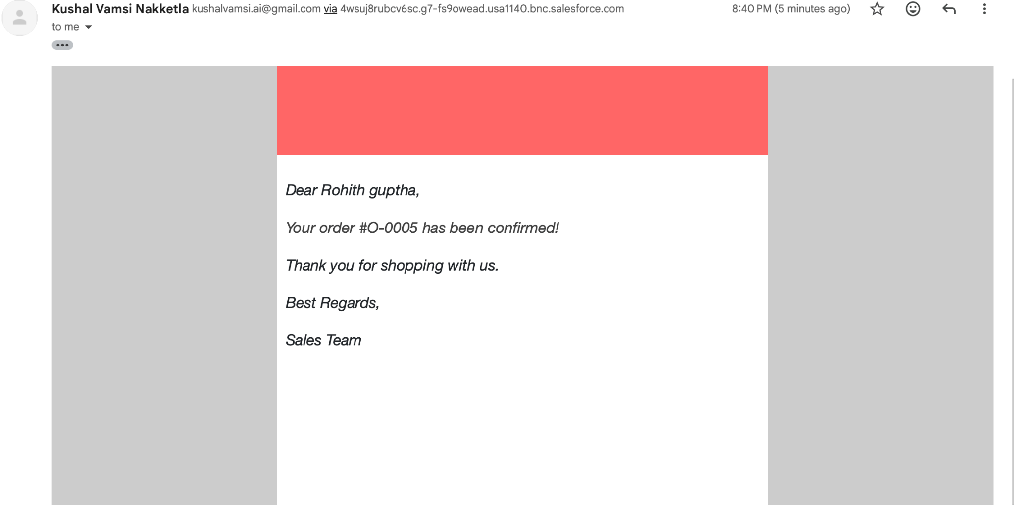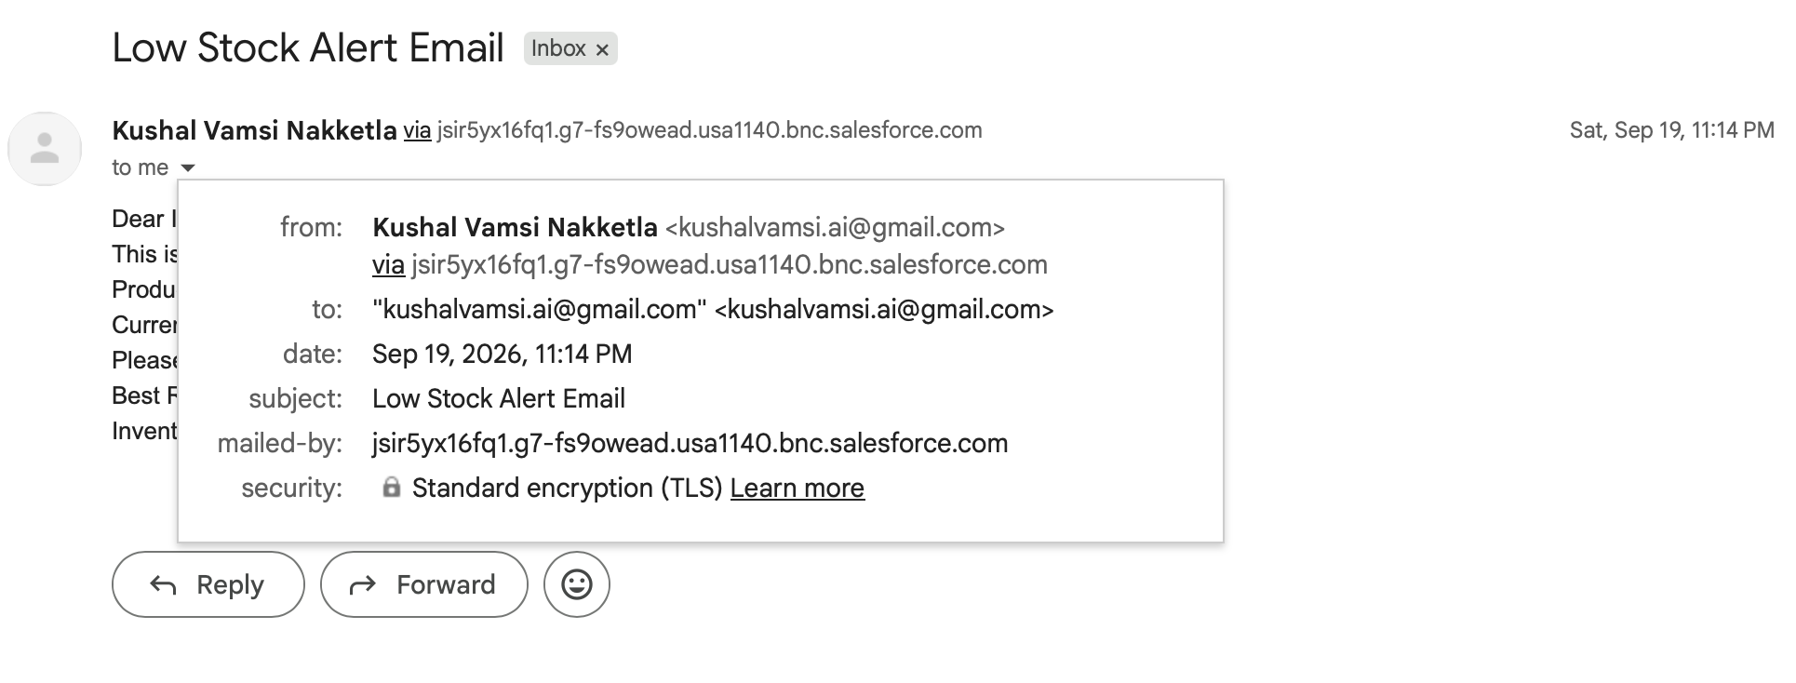
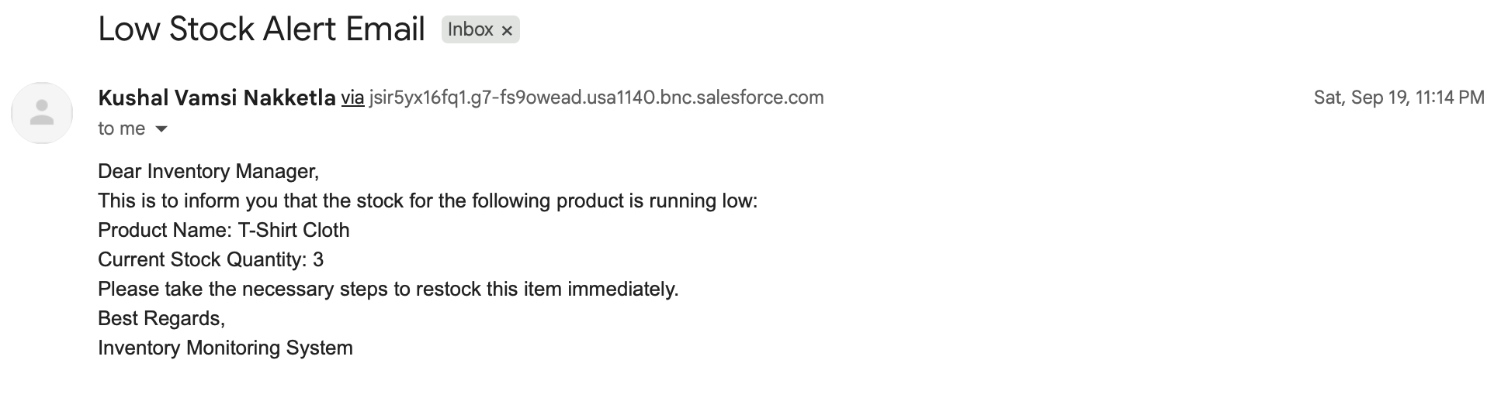
Figure 26 Automated Email Evidence

10.2 Scheduled Automation and Batch Results
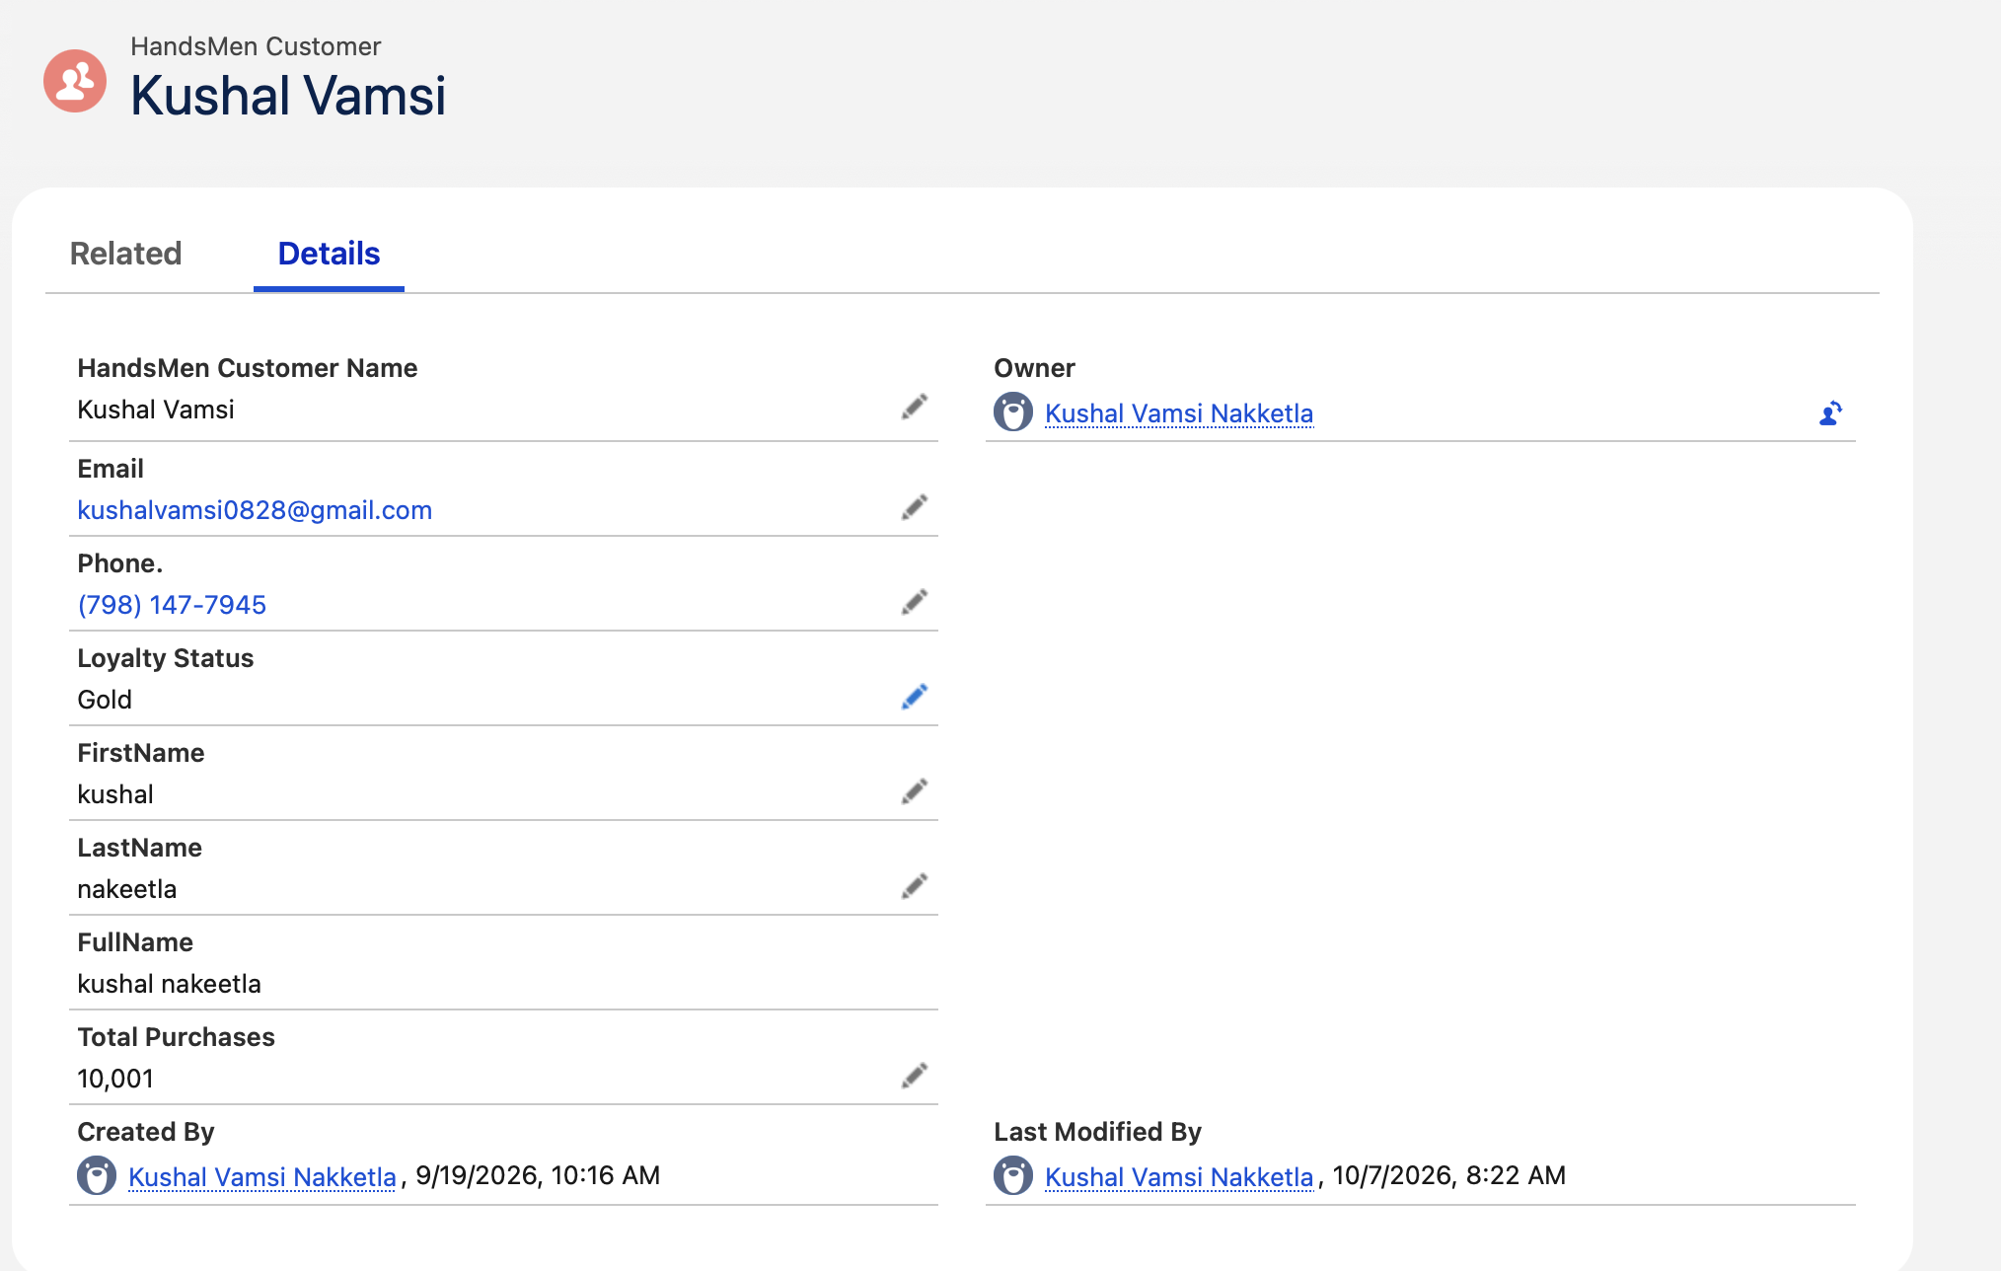
Figure 27 Loyalty Status Update Result
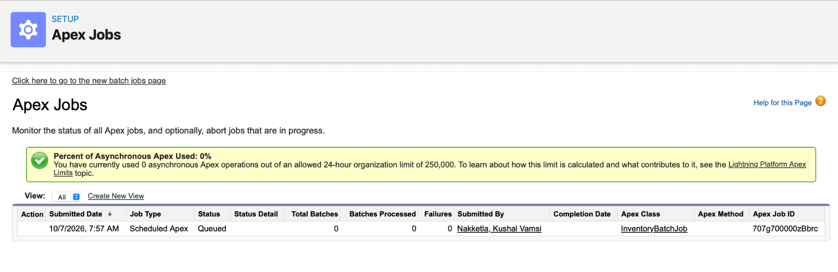
Figure 28 Batch Job Execution Result

11 Conclusion
The HandsMen Threads Salesforce project provides a practical CRM and operations solution for a fashion business. It organizes customer, product, order, inventory, and campaign data; applies validation and formula logic; controls access with Salesforce security features; automates customer and stock communication; and uses Apex for business rules and bulk processing.
Together, the configuration, automation, development, and testing evidence demonstrate core Salesforce Platform Developer skills. The completed screenshot set will give the reviewer a clear path from the data model and security design to working automation and functional outcomes.

